H.T No
Regulations:
A20

Sreenidhi Institute of Science and Technology
(An Autonomous Institution)
Code No: 8KC81 Date: 12-July-2023 (FN)

B.Tech III-Year I- Semester External Examination, July - 2023 (Supplementary)
STRUCTURAL ANALYSIS (CIVIL)

Time: 3 Hours Max.Marks:70

Note: a) No additional answer sheets will be provided.
b) All sub-parts of a question must be answered at one place only, otherwise it will not be valued.
c) Missing data can be assumed suitably.
Bloom's Cognitive Levels of Learning (BCLL)

Remember | L1 | Apply | L3 | Evaluate | L5
Understand | L2 | Analyze | L4 | Create | L6

Part - A Max.Marks:20

Answer all QUESTIONS.

 |  | BCLL | CO(s) | Marks
1 | Define Degree of Indeterminacy. | L1 | CO1 | [2M]
2 | What is the effect of sinking of support for fixed beam? | L1 | CO2 | [2M]
3 | Write the sign conventions to be considered in slope deflection method. | L1 | CO3 | [2M]
4 | What is meant by carryover moment? | L1 | CO4 | [2M]
5 | Define Stiffness of a joint. | L1 | CO5 | [2M]
6 | List out the characteristic of influence line diagram. | L1 | CO6 | [2M]
7 | Differentiate between propped cantilever beam, cantilever beam and fixed beam | L1 | CO2 | [2M]
8 | How do you account for sway in slope deflection method for portal frames? | L1 | CO4 | [2M]
9 | Define Rotation factor. | L1 | CO5 | [2M]
10 | Write the advantages of Kani’s method ? | L1 | CO5 | [2M]

Part – B Max.Marks:50
ANSWER ANY FIVE QUESTIONS. EACH QUESTION CARRIES 10 MARKS.

 |  |  | BCLL | CO(s) | Marks
11. |  | A cantilever beam of length 15m carries an UDL of 5 kN/m over the entire span. The free end of the cantilever is supported on a prop. Two concentrated loads of 40kN and 60kN acts on the beam at a distance of 5m and 8m from the fixed end. Draw the shear force and bending moment diagram. | L4 | CO1 | [10M]
12. |  | A fixed beam of length 5m carries a point load of 20kN at a distance of 2m from A. Determine the fixed end moments and deflection under the load, if the flexural rigidity of the beam is 1x10⁴ kN/m² | L4 | CO2 | [10M]
13. |  | Analyze the continuous beam shown in figure by slope deflection method  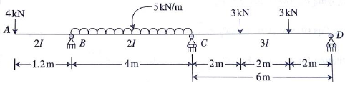 | L4 | CO3 | [10M]
14. |  | Analyze the continuous beam shown in the figure using moment distribution method and draw B.M.D.  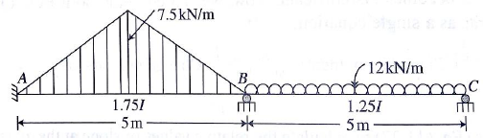 | L4 | CO4 | [10M]
15. |  | Analyze the structure shown in figure using Kani’s method and draw BMD.  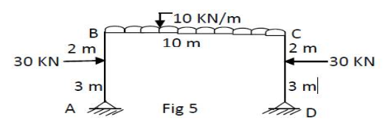 | L4 | CO5 | [10M]
16. |  | A train of wheel loads shown in the figure crosses a girder of 30m span with 120 kN load leading. Determine the value of :  i) Maximum bending moment at the section 6m from the left end of the girder.  ii) Absolute maximum bending moment of the girder.  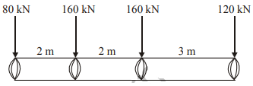 | L4 | CO6 | [10M]
17. |  | Analyse the continuous beam shown in the figure below owing to effect of 30mm settlement at support B by slope-deflection method.  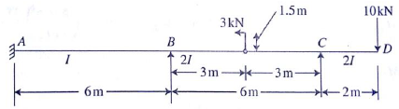 | L4 | CO1 | [10M]
18. |  | Analyze the frame shown below by moment distribution method and draw the B.M.D.  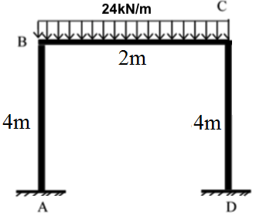 | L4 | CO4 | [10M]

-- 00 -- 00 –

